2023

Midterm

Progressive Assessment

English

K1

Name: ___________________________

Class: ___________________________

Marks: ___________________________

1. Which picture begins with the given letter? Put a tick (√). [10 marks]

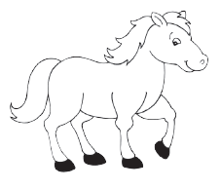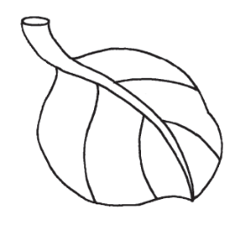

l

m

k

f

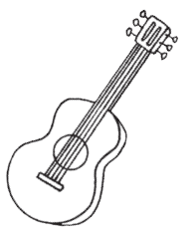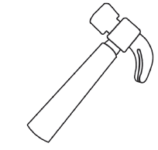

g

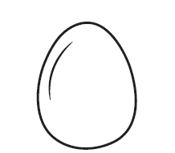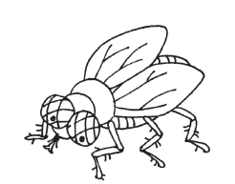

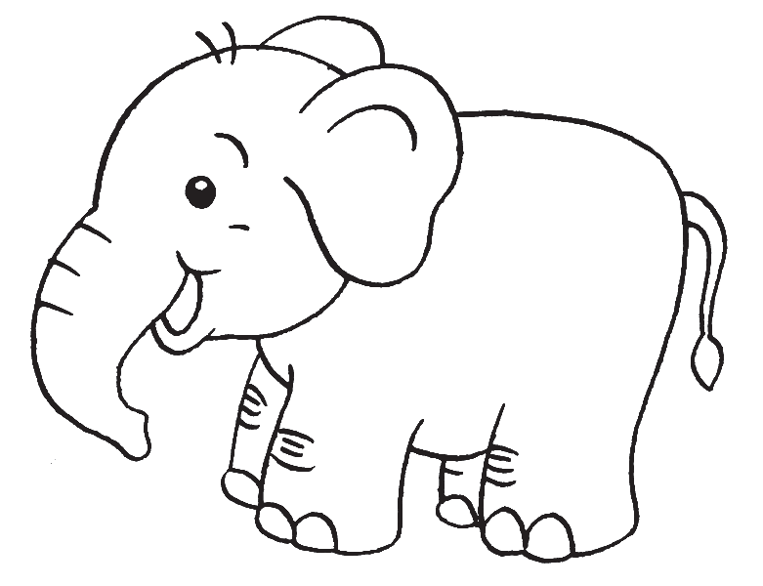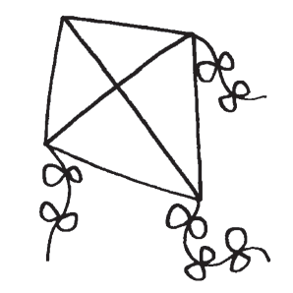

1. 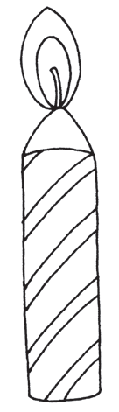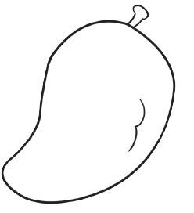
2. Colour the box that has the correct beginning letter for each picture. [12 marks]

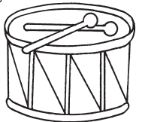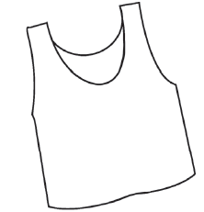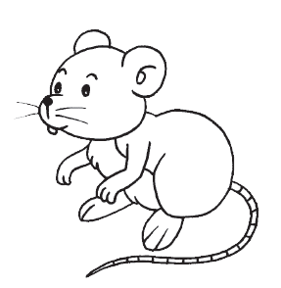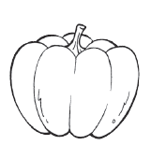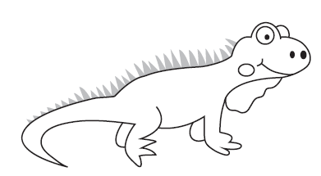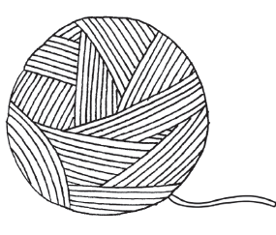

i

g

y

z

d

e

w

v

r

m

p

q