**Letters a to f**

Trace the letters. Then, match the letters to the correct pictures.



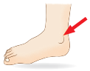

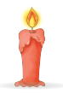



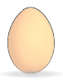

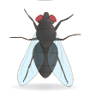

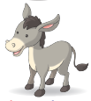

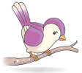

**Letters g to l**

Circle the correct beginning letter for each picture.

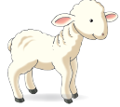

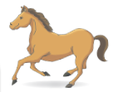

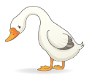

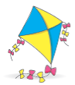

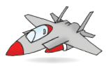



i

l

h

k

j

g

l

k

g

j

k

i

**Letters m to s**

Name the pictures. Fill in the blanks with the correct beginning letters.

___ est

___ ose

___ un

___ uail

___ ango

___ ot

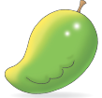

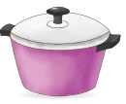

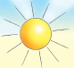

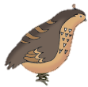

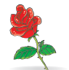

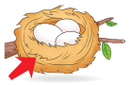

p

m

q

n

s

r