**Letters Aa to Ff**

What letter does each picture begin with? Write its capital letter in the blank.

__lbow

__erry

__olphin

__xe

__ow

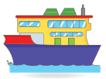

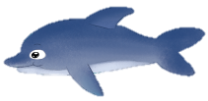

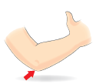

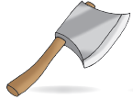

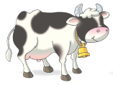

**Letters Gg to Ll**

What letter comes next? Fill in each box with the correct capital letter. Match the letter to its small letter. Then, match the small letter to the picture that begins with it.

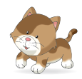

A

B

C

k

H

I

J

E

F

G

I

J

K

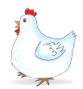

d

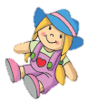

l

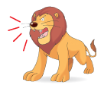

g

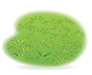

D

E

F

h

**Letters Mm to Ss**

Match the pictures that begin with the same letters.

