**Unit 1: About Me**

Look at the pictures. Write the correct words to complete the sentences.

I have ten ____________.

I have one ____________.

I am a ____________.

I am a ____________.

fingers boy girl nose

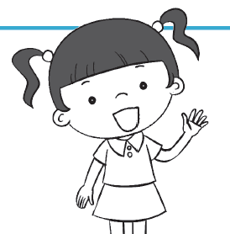

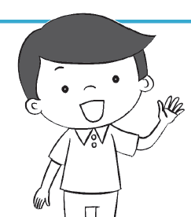

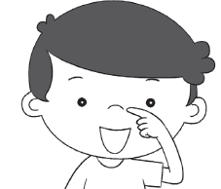

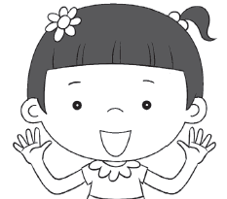

**Unit 2: My Family and I**

What should child A say? Match the pictures to the correct greetings.

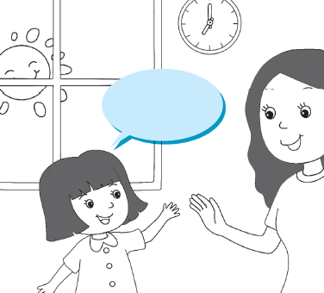

Good evening, Grandfather.

Good night, Father.

Good afternoon, Sister.

A

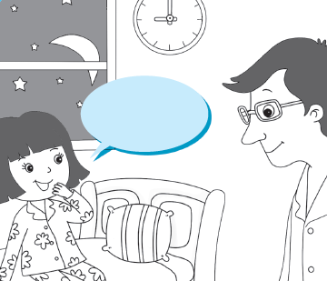

Good morning, Mother.

A

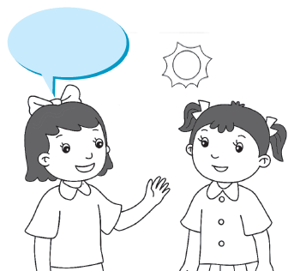

A

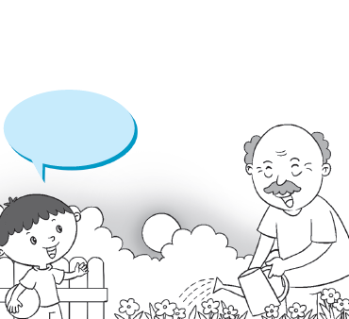

A

**Unit 3: My House**

Put a tick (/) for the correct answer. 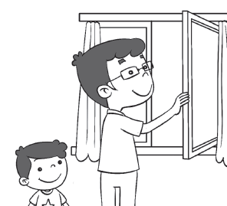

Close the window.

Close the gate.

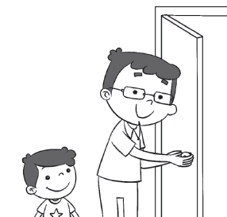

Close the window.

Close the door.

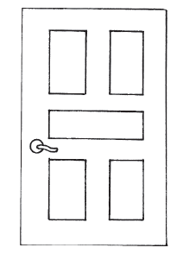

This is a roof.

This is a door.

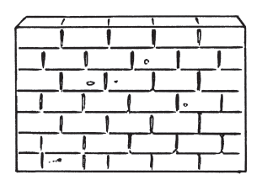

This is a wall.

This is a gate.