**Unit 1: At Home**

Circle the things that belong in the living room.

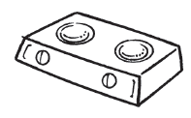 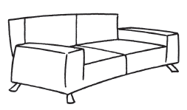

 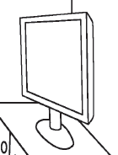 

Tick (✓) the correct sentences.

I sweep the sofa.

I sweep the floor.

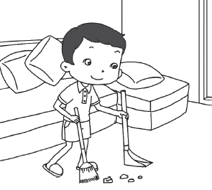



Sister sleeps in the bathroom.

Sister sleeps in the bedroom.

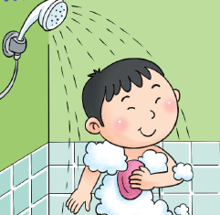

My brother is in the bathroom.

My brother is

in the kitchen.

**Unit 2: Mealtimes**

Name the items. Write the correct words in the boxes.

sandwich vegetables fruits juice

bread rice noodles fish



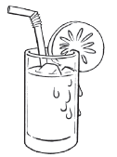

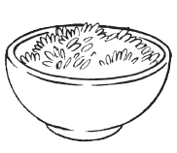

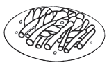

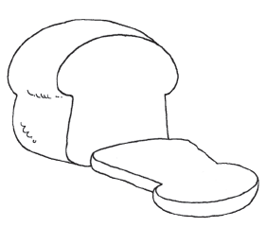

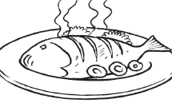

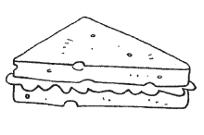

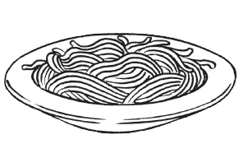

**Unit 3: A Walk in the Park**

Rearrange the letters to form the complete words.





n r u

g s i n w

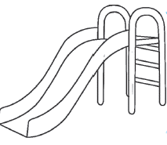

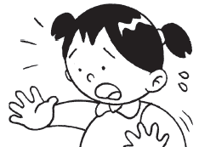

s c d a r e

l s i d e

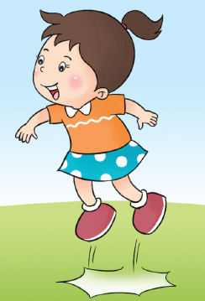

m u j p