**Unit 1: Things to wear.**

Match. Then, based on the words given, colour the pictures correctly.

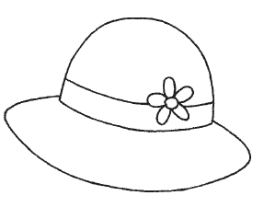

green skirt

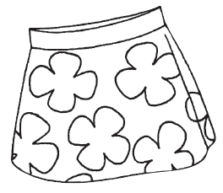

pink hat

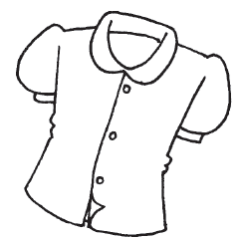

red blouse

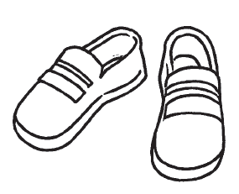

blue cap

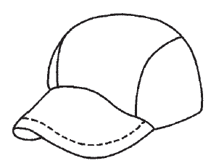

black shoes

**Unit 2: My Birthday**

Fill in the blanks with the correct words to complete the sentences.

behind under beside

in Thank you

“_______________”, says Adam.

The girl is _______ the boy.

The balloon is _______ the table.



The card is _______ the cake.

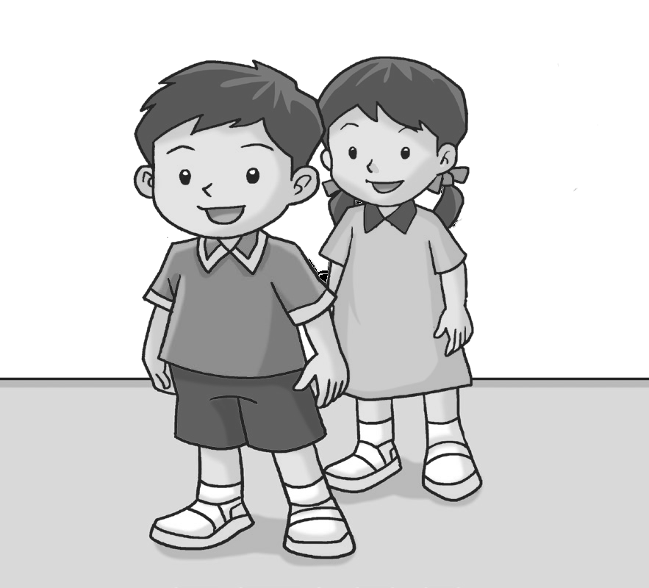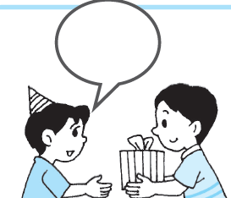

Adam

**Unit 3: On the Farm**

What sounds do the animals make? Fill in the boxes with the correct sounds.

Then, match the animals to their babies.

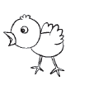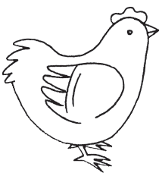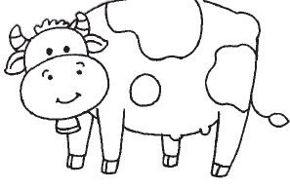



Moo! Quack! Neigh! Cluck!

