2023

Final Term

Progressive Assessment

English

K2

Name: ___________________________

Class: ___________________________

Marks: ___________________________

1. Match the people to the appropriate places. [ 8 marks]

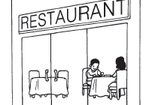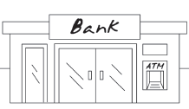

I want to post a letter.

I want to borrow some books.

I want to buy some food.

I need some money.

1. Rearrange the letters to form the correct words. Then, write the words in the boxes. [10 marks]



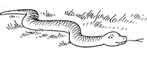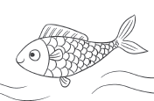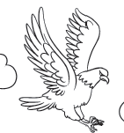

e g a e l

s h f i

s k n a e

z b e r a

g e r t i