**Unit 1: Around Town**

Name the places. Fill in the boxes with the correct words.

hospital fire station bank

petrol station police station school

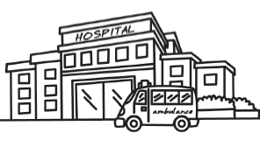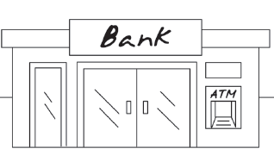

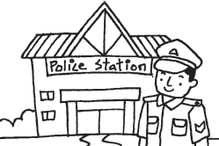

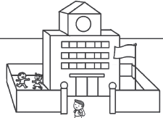

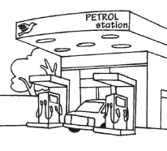

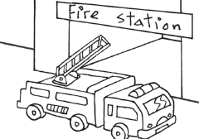

**Unit 2: Going Shopping**

Circle the correct words.

This is a **bookshop / bakery.**

It sells **flowers / books.**

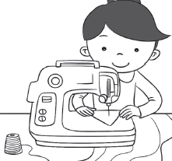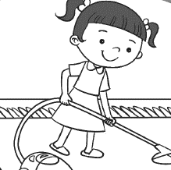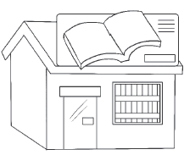

This is a **flower shop / toyshop.**

It sells **bread / toys** .

She uses a **rice cooker / sewing machine** to sew clothes.

Rina uses a **vacuum cleaner / oven**  to clean the carpet.

**Unit 3: To the Zoo**

Put a tick (/) for the correct answer.

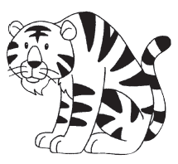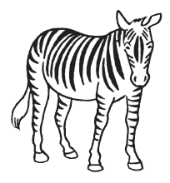

A giraffe has a long neck.

A giraffe has sharp teeth.

A zebra has yellow stripes.

A zebra has black stripes.

A tiger eats plants.

A tiger eats meat.

A crocodile eats meat.

A crocodile eats plants.