**2023**

**Final Term**

**Progressive Assessment**

数学

**Maths**

**K1**

姓名 Name **:_______________________**

班级 Class **:_______________________**

分数 Marks **:** **____________/100**

1. 数一数每组的物品。这两组的物品数量是相等的吗？如果是相等的，在空格里写上‘=’符号；然后，把有比较少物品的组合圈起来。[10分]

Count the things in each group. Are the two groups equal in number? If ‘Yes’, write the word ‘equal’ in the box. If ‘No’, circle the group that has less things. [10 marks]







Kids Shine K1 Moral Midterm Assessment



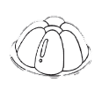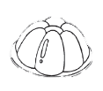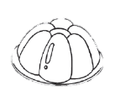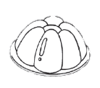



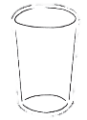

1. 把数字从最小到最大正确地排列。[3分]

Write the numbers in the correct order from smallest to biggest. [3 marks]



3

2

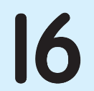

5

7

8



1. 把数字从最大到最小正确地排列。[3分]

Write the numbers in the correct order from biggest to smallest. [3 marks]

7

3

5

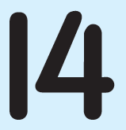

8

2



6

1. 什么数字是在8之前、在5之后？写一写。[4分]

What numbers come before 8 and after 5? Write. [4 marks]