**2023**

**Final Term**

**Progressive Assessment**

**数学**

**Maths**

**K2**

**姓名Name : ______________________________**

**班级Class : ______________________________**

**分数Marks : ________/100**

1. 把数字从最大排列到最小，写一写。[4分]

Arrange and write the numbers from the biggest to the smallest. [4 marks]



38

36

37



35

33

32

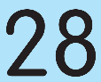

25

27

28

26

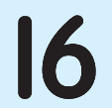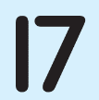



1. 填写缺少的数字以完成减法算式。把算式画线连一连正确的答案。[12分]

Fill in the missing number to complete the subtraction sentence. Match the sum to the correct answer. [12 marks]

35 –



= 5

32 –

= 20

= 20

25 –

= 30

37 –



= 20

–