单元1 Unit 1

看一看题目所给的序数，圈出正确的物品。

Look at the ordinal number given. Circle the correct thing.

第一 1st

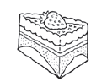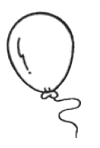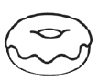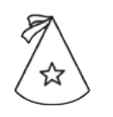

第二

2nd

第一 1st

第八

8th

第一 1st

第五

5th

第一 1st

第四

4th

第一 1st

第六

6th

第一 1st

第九

9th

单元2 Unit 2

哪一个是缺少的立体？圈一圈以完成模式。

What is the missing 3D shape? Circle it to complete the pattern.

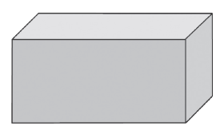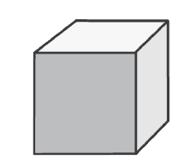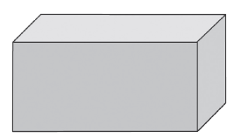

?



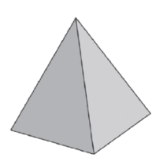

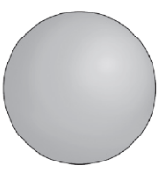

?









?



单元3 Unit 3

加一加，减一减。把有相同答案的算式画线匹配。

Let’s add or subtract. Then, match the sums that have the same answer.

18 – 3 =



17 – 6 =

19 – 1 =

20 – 0 =

20 – 4 =

19 – 2 =

16 – 2 =

20 – 1 =

14 – 2 =

11 + 1 =

9 + 24 =

10 + 4 =

15 + 2 =

12 + 7 =

17 + 1 =

13 + 2 =

10 + 10 =

11 + 5 =















