2023
Final Term
Progressive Assessment

数学
Maths
K2

姓名Name : ______________________________
班级Class : ______________________________
分数Marks : ________/100
- 把数字从最大排列到最小，写一写。[4分]
Arrange and write the numbers from the biggest to the smallest. [4 marks]



38
36
37

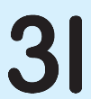

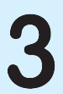
35
33
32

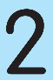

25
27
28
26


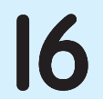
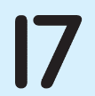


- 填写缺少的数字以完成减法算式。把算式画线连一连正确的答案。[12分]
Fill in the missing number to complete the subtraction sentence. Match the sum to the correct answer. [12 marks]

35 –

= 5

5
32 –
= 20

30
= 20
25 –


= 30
37 –



= 20
–

