**2023**

**Midterm**

**Progressive Assessment**

**科学**

**Science**

**K2**

**姓名Name : ______________________________**

**班级Class : ______________________________**

**分数Marks : ________/100**

1. 这些衣物是用什么制成的？连一连。[6分]

What are the things made of? Match correctly. [6 marks]

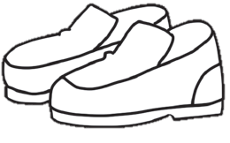

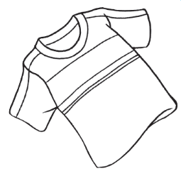

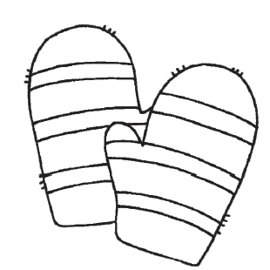

棉花cotton

动物的皮animal skin

羊毛wool

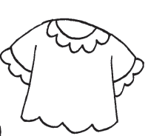

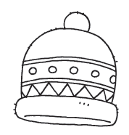

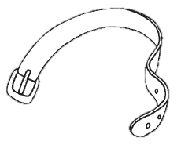

1. 哪种活动显示了水的用途？把格子涂上颜色。[6分]

Which activities show the uses of water? Colour the boxes. [6 marks]

