**2023**

**Midterm**

**Progressive Assessment**

**科学**

**Science**

**K1**

**姓名Name : ______________________________**

**班级Class : ______________________________**

**分数Marks : ________/100**

1. 把有正确词语的格子涂上颜色。[5分]

Colour the boxes that have the correct words. [5 marks]

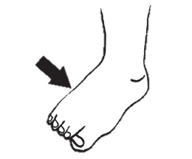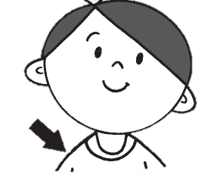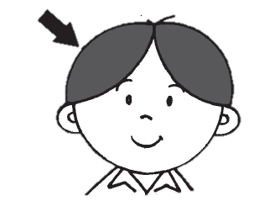

手hand

脚foot

肩膀shoulder

脚趾toes

眉毛eyebrow

头发hair

眼睛eyes

口mouth

鼻子nose

口mouth





1. 我们使用身体部位来做什么？在格子里填上正确的字母。[8分]

What do we use the body parts for? Fill in the boxes with the correct letters.

[8 marks]

看东西to see

尝味道to taste

听声音to hear

闻气味to smell







