**2023**

**Final Term**

**Progressive Assessment**

**科学**

**Science**

**K1**

**姓名Name : ______________________________**

**班级Class : ______________________________**

**分数Marks : ________/100**

1. 哪个是生物？把它们圈一圈。哪个是非生物？把它们画叉。[12分]

Which ones are living things? Circle. Which ones are non-living things?

Cross (x) them out. [12 marks]

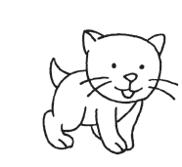

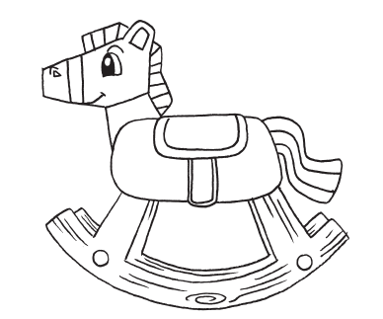

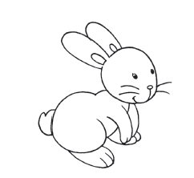

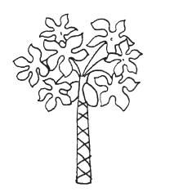

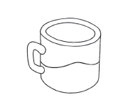

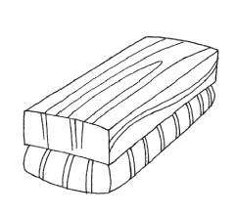

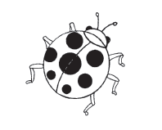

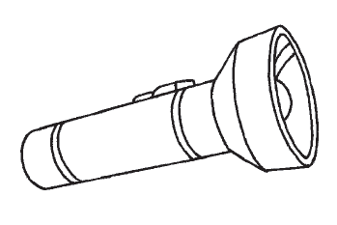

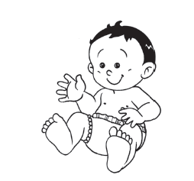

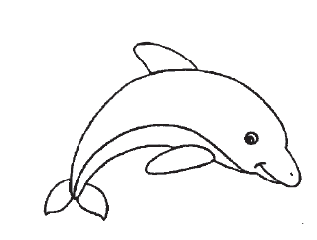

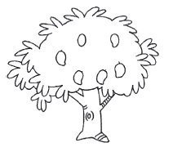

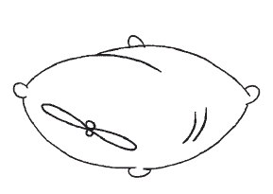

1. 看一看图片，画线匹配正确的句子。[8分]

Look at the pictures. Match them to the correct sentences. [8 marks]

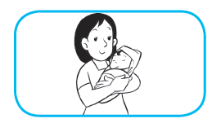

生物会吃东西和喝水。

Living things can eat and drink.

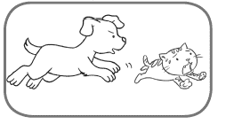

生物会成长。

Living things can grow.

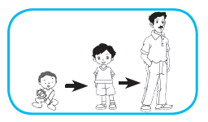

生物会自己移动。

Living things can move by themselves.

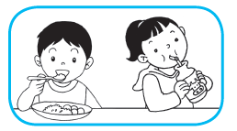

生物会生育。

Living things can have young.