单元 1 Unit 1

哪一个是生物？写上”L“。哪一个是非生物？写上“N“。

Which ones are living things? Write ‘L’. Which ones are non-living things? Write ‘N’.

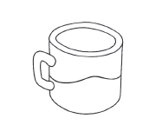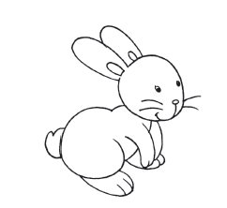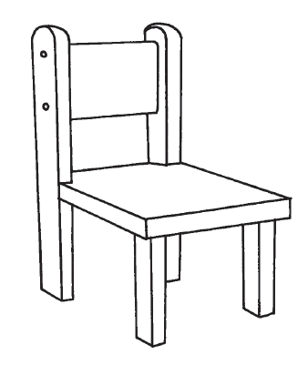

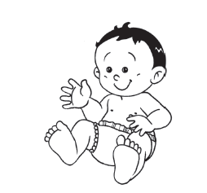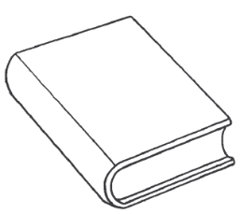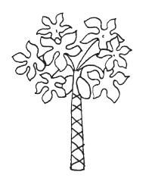

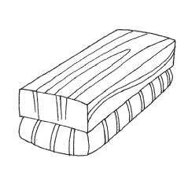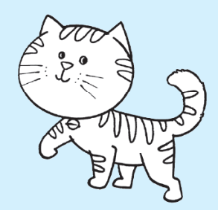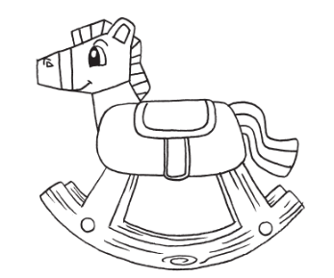

单元2 Unit 2

把对我们有益的食物圈起来；对我们无益的食物则画(X)。

Circle the food items that are good for us.

Cross out (X) the food items that are not good for us.

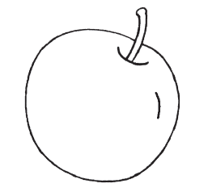 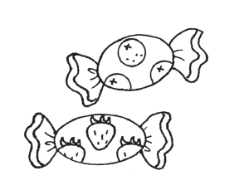 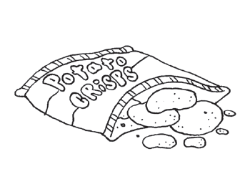 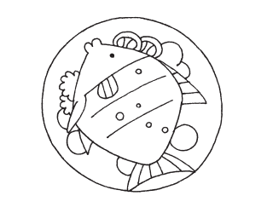

把来自动物的食物打(✓)；来自植物的食物画(X)。

Which food items come from animals? Put a tick (✓).

Which food items come from plants? Put a cross (X).

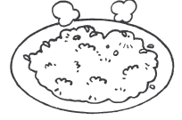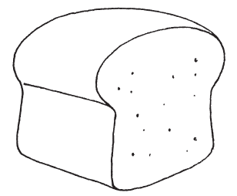

单元3 Unit 3

哪些鸟会飞？哪些鸟不会飞？把字母写在正确的空格里。

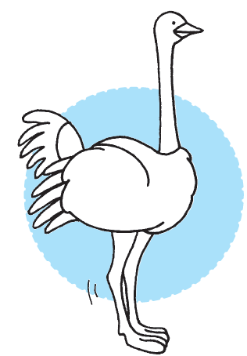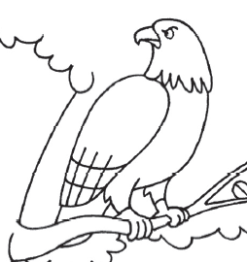Which birds can fly? Which birds cannot fly? Write the letters in the correct columns.





|  |  |
| --- | --- |
| 会飞的鸟  Birds that can fly | 不会飞的鸟  Birds that cannot fly |
|  |  |