单元1 Unit 1

这些物品是用什么制成的？把字母写在正确的格子里。

What are the items below made of? Write the letters in the correct boxes.

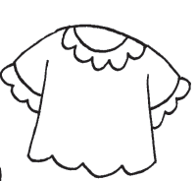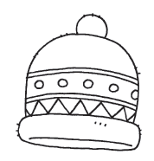

动物的皮

animal skin

羊毛

wool

棉花

cotton

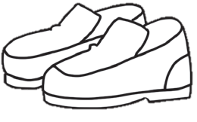

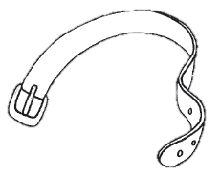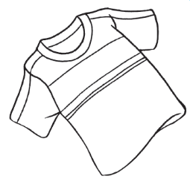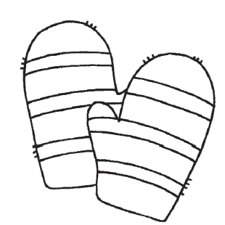

单元2 Unit 2

读一读句子，在正确的格子里打(✓)。

Read the sentences. Put a tick (✓) in the correct boxes.

|  |  |  |
| --- | --- | --- |
|  | 对  Yes | 不对  No |
| 水没有固定的形状。  Water has no shape of its own. |  |  |
| 水是红色的。  Water is red in colour. |  |  |
| 水对生物不重要。  Water is not important to living things. |  |  |
| 我们可以喝水和用水来洗东西。  We can and drink water and use it to wash things. |  |  |
| 我们不能用水来烹煮，  We cannot use water to cook. |  |  |

哪样东西会沉在水底？圈一圈。

Which ones will sink? Circle.

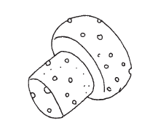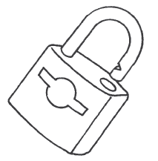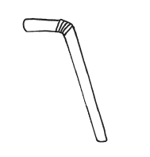

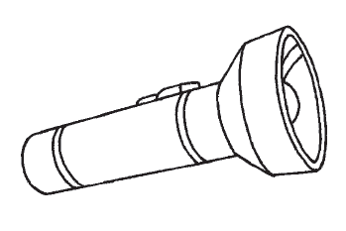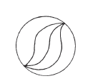

单元3 Unit 3

把家畜和家禽涂上颜色。

Colour the farm animals.