**2023**

**Final Term**

**Progressive Assessment**

**科学**

**Science**

**K2**

**姓名Name : ______________________________**

**班级Class : ______________________________**

**分数Marks : ________/100**

1. 圈出需要燃料来行驶的交通工具。[10分]

Circle the vehicles that need fuel to move. [10 marks]

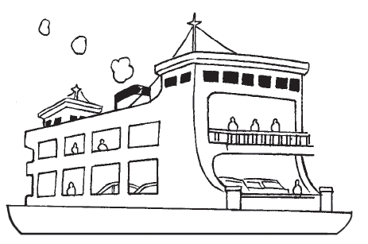

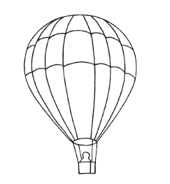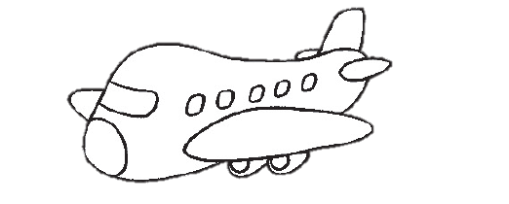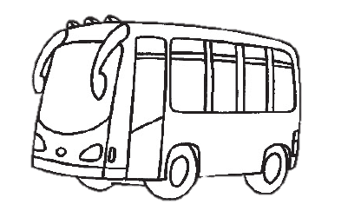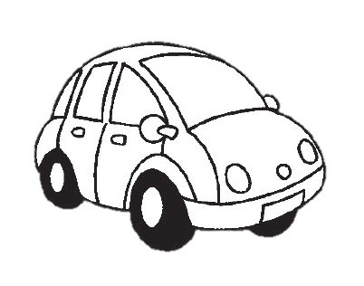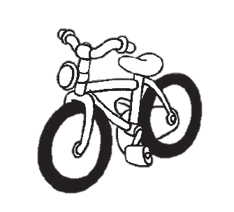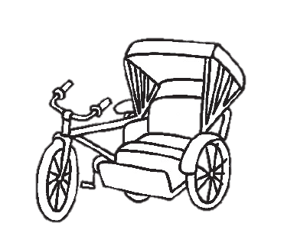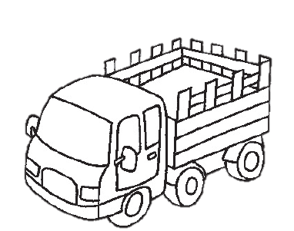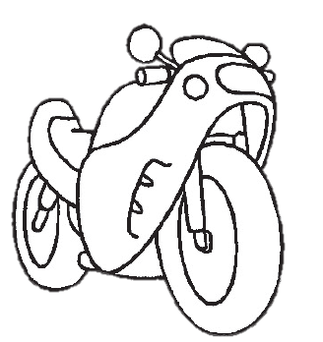

1. 看一看每张图片中的物品A，画一画它们的影子。[10分]

Look at item A in each picture. Draw its shadow. [10 marks]



A

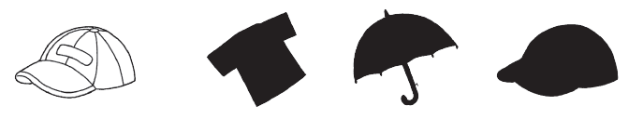

A

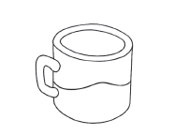

A

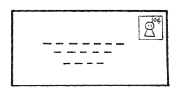

A

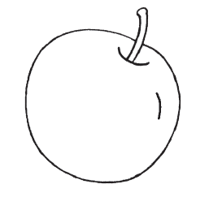

A