**单元1 关于我**

**连一连。**

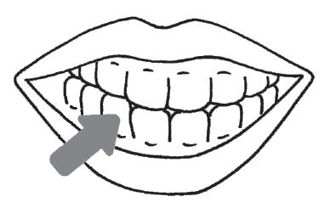

手

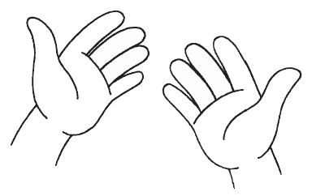

耳

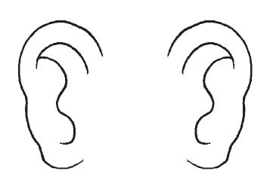

牙

**看图，写出正确的字母。**

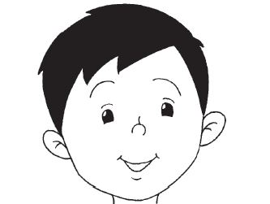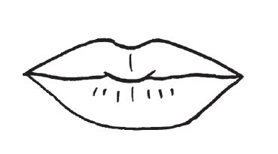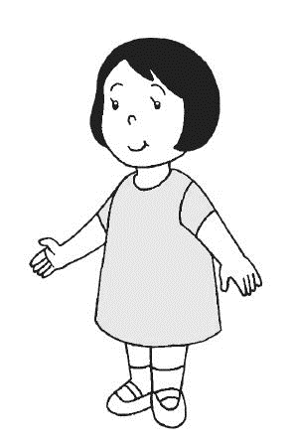

C人

B头

A口

**单元2我和我的家人**

**把正确的答案圈起来。**

|  |  |  |  |
| --- | --- | --- | --- |
|  | |  | |
| **妈妈** | **爷爷** | **妹妹** | **哥哥** |
|  | |  | |
| **奶奶** | **爸爸** | **哥哥** | **姐姐** |
|  | |  | |
| **弟弟** | **奶奶** | **奶奶** | **哥哥** |
|  | |  | |
| **姐姐** | **爷爷** | **爸爸** | **妈妈** |

**单元3我的家**

**看图，把正确的答案打✓。**

|  |  |  |
| --- | --- | --- |
|  | **窗** | **墙** |

|  |  |  |
| --- | --- | --- |
|  | **墙** | **门** |

|  |  |  |
| --- | --- | --- |
|  | **屋顶** | **门** |

|  |  |  |
| --- | --- | --- |
|  | **窗** | **屋顶** |

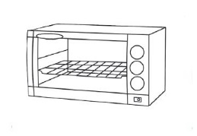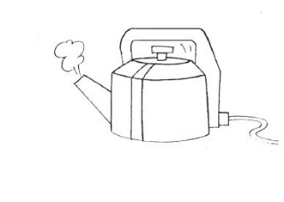**哪些东西应该在厨房里？圈一圈。**

