**2023**

**Midterm**

**Progressive Assessment**

**华文**

**Chinese**

**K2**

**姓名: _________________________**

**班级: _________________________**

**分数: _________________________**

**A看图，圈出正确的答案。**

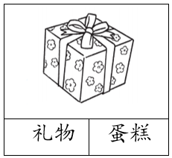

|  |  |
| --- | --- |
|  | |
| 鞋子 | 袜子 |

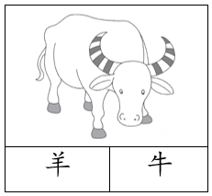

|  |  |
| --- | --- |
|  | |
| 凤梨 | 榴梿 |

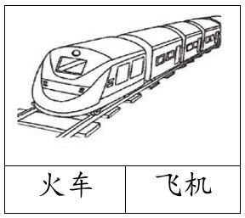

|  |  |
| --- | --- |
|  | |
| 雨天 | 阴天 |

分

6

**B看图配词，画线连一连。然后把词语写在横线上。**

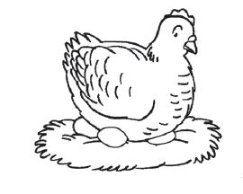

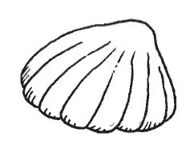

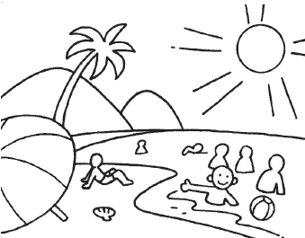

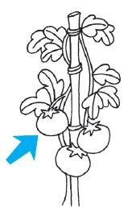



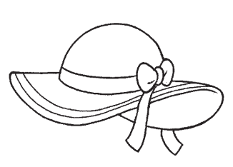

分

12