**2023**

**Midterm**

**Progressive Assessment**

道德教育

**Moral Education**

**K1**

姓名 Name **:_______________________**

班级 Class **:_______________________**

分数 Marks **:** **____________/100**

1. **小卡在起床后应该做什么？在正确的格子打 (√)。[6分]**

**What should Carl do after waking up? Tick (√) the correct box. [6 marks]**

|  |  |
| --- | --- |
| 刷牙  Brush his teeth |  |
| 吃糖果  Eat some sweets |  |
| 冲凉  Bathe |  |
| 穿上干净的衣服  Change his clothes |  |
| 跳舞  Dance |  |

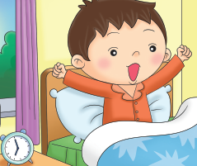

1. **这个小朋友需要什么来保持整洁？画线匹配正确的物品。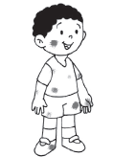[4分]**

**What does the child need to keep clean? Match him to the correct things.**

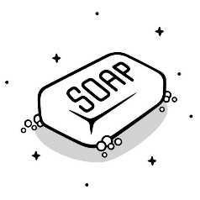**[4 marks]**

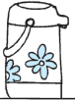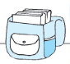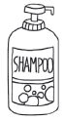

1. **看一看图片。这个小朋友应该怎么做？在正确的答案旁打 (√)。[4分]**

**Look at the picture. What should the child do? Tick (√) the correct answer.**

**[4 marks]**

|  |  |
| --- | --- |
| 照顾他的眼睛。  Take good care of his eyes. |  |
| 让自己保持干净。  Keep himself clean. |  |
| 把灯打开。  Switch on the lights. |  |

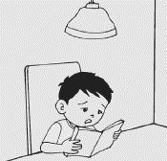

1. 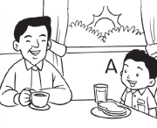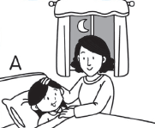**A小孩该说什么？匹配到正确的答案 。[4分]**

**What should child A say? Match the correct answer. [4 marks]**

妈妈，晚安。

Good night, Mother.

爸爸，早安。

Good morning, Father.