**2023**

**Final Term**

**Progressive Assessment**

道德教育

**Moral Education**

**K1**

姓名 Name **:_______________________**

班级 Class **:_______________________**

分数 Marks **:** **____________/100**

1. **谁应该说 “对不起”？把正确的名字圈起来。[6分]**

**Who should say ‘Sorry’? Circle the correct name. [6 marks]**

阿桥

Joe

美美

Mei

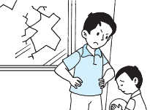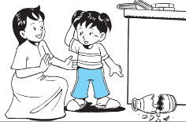

小提

Tim

莎拉

Sara

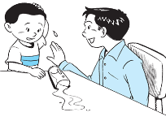

亚历

Alex

哈利

Harry

1. **读一读下面的对话。哪个小朋友在讲电话时有礼貌？有礼貌的小朋友打(/)。没礼貌的小朋友**

**打(X)。[4分]**

**Read the speech bubbles. Is each child polite on the telephone? Put a tick (√) if ‘Yes’. Put a cross (X) if ‘No’. [4 marks]**

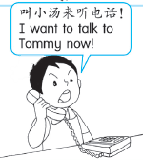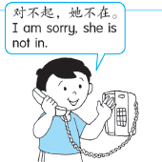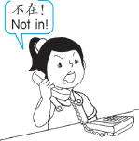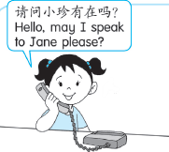

1. **看一看这张图片。哪个小朋友在打扫屋子？写出正确的字母。[3分]**

**Look at the picture. Which of the children are cleaning the house? Write the correct letters. [3 marks]**

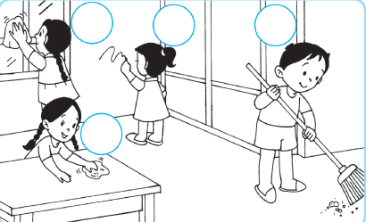

C

B

A

D

**______, _______ 和_______ 小孩保持他们家的整洁。**

Child ____, Child _____ and Child _____ keep their home clean.

1. **看一看小汤。他做得对吗？你会给他什么劝告？连一连正确的句子。[2分]**

**Look at Tom. What advice should you give him? Match the correct sentence.**

**[2 marks]**

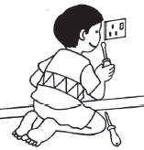

你不应该玩插座。

You should not play with sockets.

你不应该在墙壁上涂鸦。

You should not draw on the wall.

你不应该保持家里的整洁。

You should keep your home clean.