**2023**

**Mid Term**

**Progressive Assessment**

道德教育

**Moral Education**

**K2**

姓名 Name **:_______________________**

班级 Class **:_______________________**

分数 Marks **:** **____________/100**

1. **这些小朋友有穿干净的衣服吗？有的画 “😊”，没有的画“☹”。[8分]**

**Is each child wearing clean clothes? Draw a 😊 if ‘Yes’. Draw a ☹ if ‘No’.**

**[8 marks]**

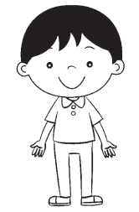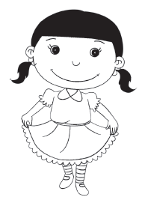

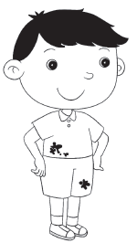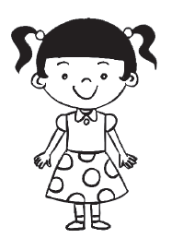

1. **哪种衣服合适穿去上学？圈一圈。[4分]**

**Which of these clothes is suitable for school? Circle it. [4 marks]**



1. **哪个小朋友做得对？把正确的圆涂上颜色。[2分]**

**Which child is doing the right thing? Colour the correct circle. [2 marks]**

