**单元1 Unit 1**

哪个小朋友有把东西放回原位？把他们圈起来，并沿线写出正确的字母。

Which child puts things back where they belong? Circle him/her. Then, trace the correct letters.

A

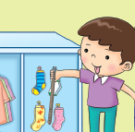

B

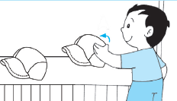

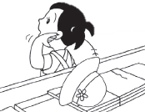

D

C

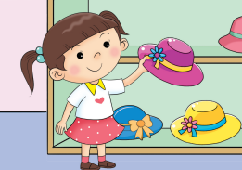

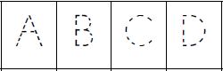

**单元2 Unit 2**

看看下图。哪个小朋友做得对？把星形涂上黄色。哪个小朋友做得不对？把星形涂上红色。

Look at the pictures. Which child is doing the right thing? Colour the star yellow. Which child is doing the wrong thing? Colour the star red.

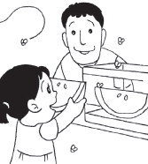

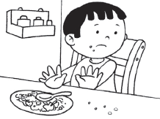

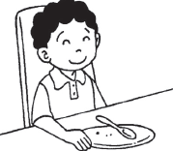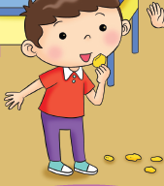

**单元3 Unit 3**

看看下图。A小孩做得对吗？把图片和正确的答案匹配起来。

Look at the picture below. Is child A doing the right thing? Match to the correct answer.

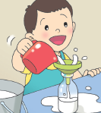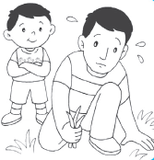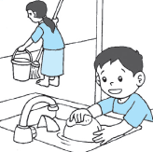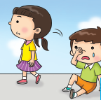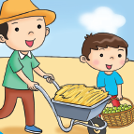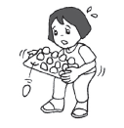

A

A

A

A

A

A

错No

对Yes