**2023**

**Final Term**

**Progressive Assessment**

道德教育

**Moral Education**

**K2**

姓名 Name **:_______________________**

班级 Class **:_______________________**

分数 Marks **:** **____________/100**

**哪个小朋友做得对？把正确的名字圈起来。[4分]**

**Which child is doing the right thing? Circle the correct name. [4 marks]**

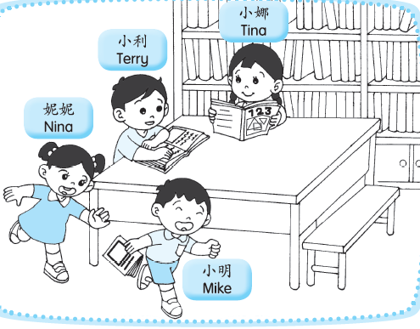

1. **A小孩在公共场合时有紧随父母吗？有的画(√)，没有的画(X)。[8分]**

**Does child A stay close to his/her parent in public places? Put a tick (√) if ‘Yes’. Put a cross (X) if ‘No’. [8 marks]**

