**单元1 Unit 1**

将图片匹配正确的句子。在空格里写出正确的字母。

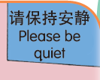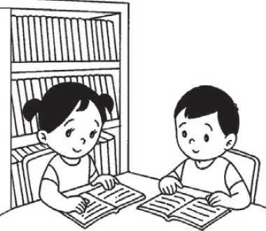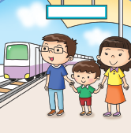Match the pictures to the correct sentences. Write the correct letters in the boxes.

A

B

C

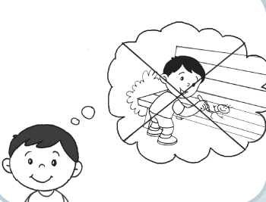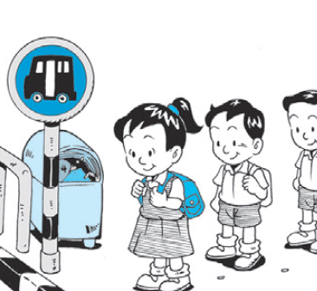

D

我排队等公共汽车或的士。

I queue up for the bus or taxi.

我爱惜公物。

I take care of public property.

我在公共场所会紧随父母。

I stay close to my parents in public places.

我不在公共场所吵闹。

I should not make noise in certain public places.

**单元2 Unit 2**

读一读下面的句子，然后把句子和正确的图片匹配起来。

Read the sentence. Then, match the sentence to the correct picture.

我小心使用自动扶梯。

I am careful when using the escalator.

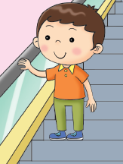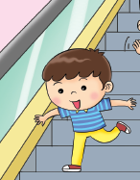

看看下图。A女士应该给男孩什么劝告？把字母“A”写在圆圈里。

Look at the picture. What advice does lady A give to the boy? Write the letter ‘A’ in the circle.

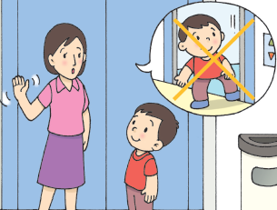

走进电梯前，我们应该要看清楚。

We should not look before stepping into the lift.

不要用你的脚来阻止电梯门关闭。

Never use your foot to stop the lift doors.

A

**单元3 Unit 3**

A小孩做得对吗？把“对”或“不对”涂上颜色。  
Is child A doing the right thing? Colour ‘Yes’ or ‘No’.

A

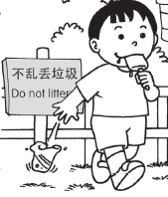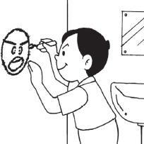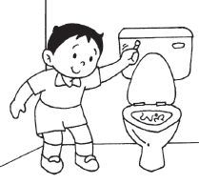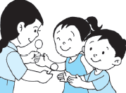

A

A

A

A

对

Yes

对

Yes

不对

No

对

Yes

不对

No

对

Yes

不对

No

对

Yes

不对

No

不对

No