2023
Final Term
Progressive Assessment
道德教育
Moral Education
K1

姓名 Name :_______________________
班级 Class :_______________________
分数 Marks : ____________/100

- 谁应该说 “对不起”？把正确的名字圈起来。[6分]
Who should say ‘Sorry’? Circle the correct name. [6 marks]
阿桥
Joe
美美
Mei
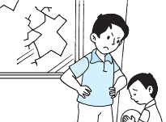
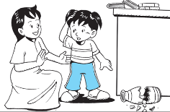
小提
Tim
莎拉
Sara

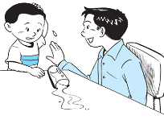
亚历
Alex
哈利
Harry

- 读一读下面的对话。哪个小朋友在讲电话时有礼貌？有礼貌的小朋友打(/)。没礼貌的小朋友
打(X)。[4分]
Read the speech bubbles. Is each child polite on the telephone? Put a tick (√) if ‘Yes’. Put a cross (X) if ‘No’. [4 marks]

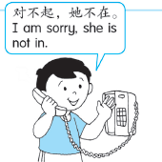
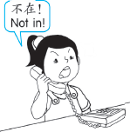
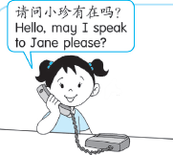
- 看一看这张图片。哪个小朋友在打扫屋子？写出正确的字母。[3分]
Look at the picture. Which of the children are cleaning the house? Write the correct letters. [3 marks]

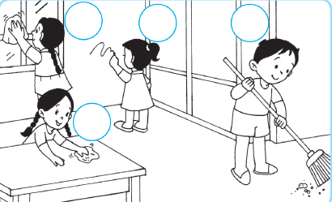
C
B
A

D

______, _______ 和_______ 小孩保持他们家的整洁。
Child ____, Child _____ and Child _____ keep their home clean.

- 看一看小汤。他做得对吗？你会给他什么劝告？连一连正确的句子。[2分]
Look at Tom. What advice should you give him? Match the correct sentence.
[2 marks]
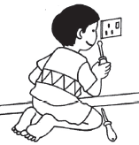
你不应该玩插座。
You should not play with sockets.
你不应该在墙壁上涂鸦。
You should not draw on the wall.
你不应该保持家里的整洁。
You should keep your home clean.

