**单元1 Unit 1**

小朋友应该对他的爸爸说什么？在正确的句子打(√) 。

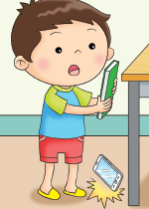What should the child say to his father? Tick (√) the correct sentence.

对不起，爸爸。

I am sorry, Father.

谢谢，爸爸。

Thank you, Father.

哪个小朋友做得对？把正确的图片圈起来。

Which of the children are doing the right thing? Circle the pictures.

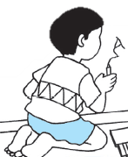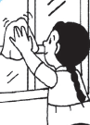

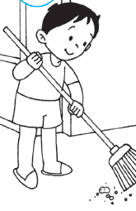

**单元2 Unit 2**

这些小朋友做得对吗？把对的图片圈起来，不对的图片打 (X) 。

Is each child doing the right thing? Circle the picture if ‘Yes’. Cross out (x) the picture if ‘No’.

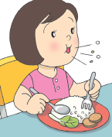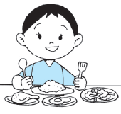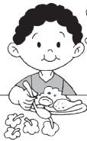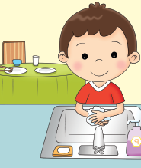

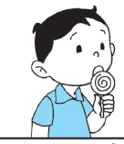

**单元3 Unit 3**

A小孩应该怎么做？在正确的句子涂上颜色。

What should the child A do? Colour the correct sentence.

轮到我了。

It is my turn.

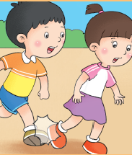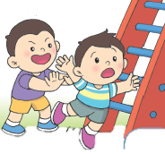

我应该天天运动。

I should exercise every day.

对不起。

I am sorry.

A

A

我应该安全地玩耍。

I should play safely.

我应该原谅他人。

I should be forgiving.

我应该排队等候。

I should wait for my turn.