2023
Mid Term
Progressive Assessment
道德教育
Moral Education
K2

姓名 Name :_______________________
班级 Class :_______________________
分数 Marks : ____________/100
- 这些小朋友有穿干净的衣服吗？有的画 “😊”，没有的画“☹”。[8分]
Is each child wearing clean clothes? Draw a 😊 if ‘Yes’. Draw a ☹ if ‘No’.
[8 marks]

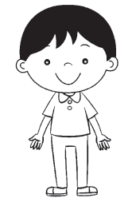
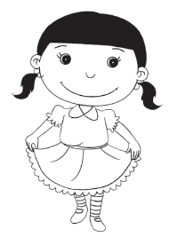

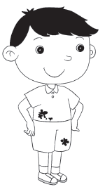
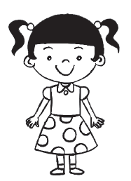

- 哪种衣服合适穿去上学？圈一圈。[4分]
Which of these clothes is suitable for school? Circle it. [4 marks]


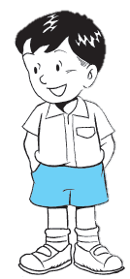



- 哪个小朋友做得对？把正确的圆涂上颜色。[2分]
Which child is doing the right thing? Colour the correct circle. [2 marks]

