DAILY LESSON PLAN
MATHEMATICS FORM 3
CLASS |  |  | DAY | Choose an item.
WEEK | Choose an item. |  | TIME
DATE | Click or tap to enter a date. |  | DURATION (minutes)
LEARNING AREA | Relationship and Algebra
UNIT/TOPIC | Straight Lines
CONTENT  STANDARDS | 9.1 Straight Lines | LEARNING STANDARDS |  | 9.1.1, 9.1.2
LEARNING OBJECTIVES | At the end of learning, students will be able to:  - Make connection between the equation, y = mx + c, and the gradient and y-intercept, and hence make generalisation about the equation of a straight line.  - Investigate and interpret the equations of straight lines in other forms such as ax + by = c and $\frac{x}{a}+\frac{y}{b}=1$, and change to the form of y = mx + c, and vice versa.
ACTIVITY | Starter:  Teacher reviews the lesson on the topic of Form 2 “Gradient of a Straight Line”, and explains the meaning of gradient of straight line, m.  Activity:  - Each student is given a written card with four linear functions:  y = 3x – 2, y = –4x + 5, y = 2x + 4, y = –5x – 3  - Students draw graph for each of the linear functions individually.  - Students are required to identify the values of the gradient and the y-intercept for each of the linear functions individually.  - Students discuss with their partner and present their works.  - Teacher uses the Simulation (Slope-intercept) on ePelangi+ to simulate the graph of each function. The teacher then explains the connection between the equation y = mx + c, with gradient m and y-intercept, c.  - Teacher demonstrates how to change the equation in the form ax + by = c and to the form y = mx + c and vice versa.  - Teacher asks students to do exercises in the workbook and textbook.  Closure:  Teacher discusses all the answers.
REFLECTION | ☐ Students were able to achieve the learning objectives successfully.  ☐ Students were able to achieve the learning objectives with guidance.  ☐ Students were not able to achieve the learning objectives.

DAILY LESSON PLAN
MATHEMATICS FORM 3
CLASS |  |  | DAY | Choose an item.
WEEK | Choose an item. |  | TIME
DATE | Click or tap to enter a date. |  | DURATION (minutes)
LEARNING AREA | Relationship and Algebra
UNIT/TOPIC | Straight Lines
CONTENT  STANDARDS | 9.1 Straight Lines | LEARNING STANDARDS |  | 9.1.3, 9.1.4
LEARNING OBJECTIVES | At the end of learning, students will be able to:  - Investigate and make inference about the relationship between the points on a straight line and the equation of the line.  - Investigate and make inference about the gradients of parallel lines.
ACTIVITY | Starter:  Teacher explains that the representation of a point on a line using coordinates (x, y), where x represents the x-coordinate and y represents the y-coordinate.  Activity:  - Referring to the textbook, each student studies the research and reading about the relationship between the points on a straight line with the equation of the straight line, as well as the gradient of the parallel line.  - Teacher chooses a student to sit on the chair provided. The student will become an “expert”.  - The “expert” will answer all the questions posed by other students.  - Teacher uses the Simulation (Slope) on ePelangi+ to simulate gradients of two straight lines and demonstrates that straight lines with the same gradient are parallel.  - Teacher asks students to do exercises in the workbook and textbook.  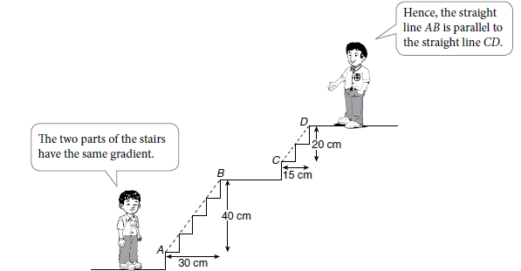  Closure:  Teacher discusses all the answers.
REFLECTION | ☐ Students were able to achieve the learning objectives successfully.  ☐ Students were able to achieve the learning objectives with guidance.  ☐ Students were not able to achieve the learning objectives.

DAILY LESSON PLAN
MATHEMATICS FORM 3
CLASS |  |  | DAY | Choose an item.
WEEK | Choose an item. |  | TIME
DATE | Click or tap to enter a date. |  | DURATION (minutes)
LEARNING AREA | Relationship and Algebra
UNIT/TOPIC | Straight Lines
CONTENT  STANDARDS | 9.1 Straight Lines | LEARNING STANDARDS |  | 9.1.5, 9.1.6, 9.1.7
LEARNING OBJECTIVES | At the end of learning, students will be able to:  - Determine the equation of a straight line.  - Determine the point of intersection of two straight lines.  - Solve problems involving straight lines.
ACTIVITY | Starter:  Teacher explains to the students that equation of a straight line can be determined when the gradient and a point on the straight line are given.  Activity:  - Teacher demonstrates how to determine the equation of a straight line.  - Teacher demonstrates how to determine the point of intersection of two straight lines using graphical method, substitution method and elimination method.  - Teacher discusses examples in solving problems involving straight lines in the textbook.  - Teacher asks students to do exercises in the workbook and textbook.  Closure:  Teacher discusses all the answers.
REFLECTION | ☐ Students were able to achieve the learning objectives successfully.  ☐ Students were able to achieve the learning objectives with guidance.  ☐ Students were not able to achieve the learning objectives.

