DAILY LESSON PLAN
MATHEMATICS FORM 5
CLASS |  |  | DAY | Choose an item.
WEEK | Choose an item. |  | TIME
DATE | Click or tap to enter a date. |  | DURATION (minutes)
LEARNING AREA | Number and Operations
UNIT/TOPIC | Consumer Mathematics: Insurance
CONTENT STANDARDS | 3.1 Risk and Insurance Coverage | LEARNING STANDARDS |  | 3.1.1
LEARNING OBJECTIVES | At the end of learning, students will be able to:  - Explain the meaning of risk and the importance of insurance coverage, hence determine the types of life insurance and general insurance for protecting a variety of risks.
ACTIVITY | Starter:  -  Activity:  - Teacher displays the following thinking map for the students to see.  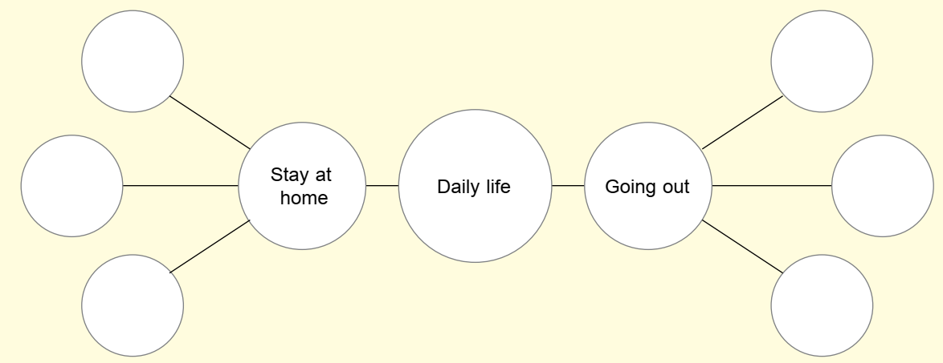  - Students are asked to think about the dangers that are exposed when we go out or stay at home.  - Students' ideas are listed on the thinking map.  - During the class discussion, teacher will begin to introduce terms such as risk, insurance, policy, premium and compensation.  - Students and teacher make a summary and conclusion in the form of a mind map of how insurance works in providing protection. Insurance should not be used as a tool to get profit also needs to be discussed.  - Teacher shows some examples of insurance policies and explains about life insurance and some types of general insurance.  Closure:  Teacher gives the conclusion of the lesson to the students. Teacher gives exercises to the students.
REFLECTION | ☐ Students were able to achieve the learning objectives successfully.  ☐ Students were able to achieve the learning objectives with guidance.  ☐ Students were not able to achieve the learning objectives.

DAILY LESSON PLAN
MATHEMATICS FORM 5
CLASS |  |  | DAY | Choose an item.
WEEK | Choose an item. |  | TIME
DATE | Click or tap to enter a date. |  | DURATION (minutes)
LEARNING AREA | Number and Operations
UNIT/TOPIC | Consumer Mathematics: Insurance
CONTENT STANDARDS | 3.1 Risk and Insurance Coverage | LEARNING STANDARDS |  | 3.1.2
LEARNING OBJECTIVES | At the end of learning, students will be able to:  - Investigate, interpret and perform calculations involving insurance rates and premiums.
ACTIVITY | Starter:  Teacher explains how to perform calculations involving insurance rates and premiums.  Activity:  - Students are given problems related to insurance rates and premiums.  *Refer to Appendix F for sample problems  - In pairs, students take turns to solve the problems and write the solution steps on the same paper.  Closure:  Teacher discusses all the answers. Teacher gives exercises to the students.
REFLECTION | ☐ Students were able to achieve the learning objectives successfully.  ☐ Students were able to achieve the learning objectives with guidance.  ☐ Students were not able to achieve the learning objectives.

Appendix F

Problems:
- Calculate the annual premium for a 40-year-old non-smoker who purchases a life insurance policy worth RM370 000 with a premium rate of RM2.66 per RM1 000 face value.

- Determine the annual premium for a 28-year-old individual who purchases a life insurance policy worth RM250 000 with a premium rate of RM1.21 per RM1 000 of coverage.

- Find the annual premium for a 35-year-old individual who buys a life insurance policy worth RM420 000 with a premium rate of RM2.72 per RM1 000 face value. If he wants to get an additional coverage for critical illness with 20% of basic face value and a premium rate of RM1.03 per RM1 000, what will be the annual premium?

- A car used in Peninsular Malaysia has an engine capacity of 1 500 cc. Using the 2015 Motor Tariff table in the textbook page 83, calculate the gross premium for a comprehensive policy of motor insurance worth RM20 000 with NCD 45%.

- A car used in Sarawak has an engine capacity of 1 800 cc. Use the 2015 Motor Tariff table in the textbook page 83, find the gross premium for a third party, fire and theft policy of motor insurance worth RM40 000 with NCD 30%.

- A car used in Sabah has an engine capacity of 2 300 cc. Using the 2015 Motor Tariff table in the textbook page 83, determine the gross premium for a third party policy of motor insurance worth RM50 000 with
NCD 25%.

Answers (Problems):
- RM984.20
- RM302.50
- RM1 228.92
- RM439.73
- RM543.69
- RM93.60

DAILY LESSON PLAN
MATHEMATICS FORM 5
CLASS |  |  | DAY | Choose an item.
WEEK | Choose an item. |  | TIME
DATE | Click or tap to enter a date. |  | DURATION (minutes)
LEARNING AREA | Number and Operations
UNIT/TOPIC | Consumer Mathematics: Insurance
CONTENT STANDARDS | 3.1 Risk and Insurance Coverage | LEARNING STANDARDS |  | 3.1.3
LEARNING OBJECTIVES | At the end of learning, students will be able to:  - Solve problems involving insurance including deductible and co-insurance.
ACTIVITY | Starter:  Teacher explains the meaning of deductible and co-insurance. Teacher explains co-insurance in property insurance and co-insurance in health insurance.  Activity:  - Students are divided into several groups.  - Each group is given a file containing questions related to deductible and co-insurance.  *Refer to Appendix G for sample questions in the file  - Students answer the questions in their respective groups.  - Questions and answers are put back into the file and distributed to other groups.  - After getting a new file from the other group, students discuss to check the answers from the other group and make corrections if any.  - Each group should respond to two or three new files.  Closure:  Teacher discusses all the answers. Teacher gives exercises to the students.
REFLECTION | ☐ Students were able to achieve the learning objectives successfully.  ☐ Students were able to achieve the learning objectives with guidance.  ☐ Students were not able to achieve the learning objectives.

Appendix G

Questions in the file:
File 1:
You have a motor insurance policy with a deductible of RM280. If you have an accident during the insurance period with a loss of RM500, will you be able to make a claim for the loss suffered? If yes, how much compensation will be received?

File 2:
You have a medical insurance policy with a deductible of RM23 000 per year and an annual limit of RM300 000. If you are hospitalised for treatment at a cost of RM10 000, will you be able to make a claim for the loss suffered? If yes, how much compensation will be received?

File 3:
You want to buy a fire insurance policy for your home. The insurable value of the house is RM430 000 with 90% co-insurance. The insurance policy has a deductible of RM1 500.
- Calculate the amount of required insurance.
- In a fire, the loss to your house is RM35 000. Calculate the compensation that will be received if you insure the house
- at the amount of required insurance,
- with RM200 000.
- You only insure the house with RM250 000. If your house has suffered a total loss, calculate the compensation that will be received.

File 4:
You have a medical insurance policy with a deductible of RM500. The co-insurance percentage participation of the policy is 75/25. If the covered medical cost is RM30 000, calculate the medical costs that have to be borne by the insurance company and yourself.

Answers (Questions in the file):

File 1:
Yes, I can make a claim for the loss suffered.
The compensation that will be received is RM220.

File 2:
No, I cannot make a claim for loss suffered.

File 3:
(a) RM387 000
(b) (i) RM33 500
(ii) RM16 587.86
(c) RM248 500

File 4:
Medical cost that have to be borne by the insurance company = RM22 125
Medical cost that have to be borne by myself = RM7 875

